Project Performance Testing
Date | 13 July 2026
Team ID
Project Name | Visualizing Housing Market Trends: An Analysis of Sale Prices and Features using Tableau
Maximum Marks | 4 Marks

Model Performance Testing:
S.No. | Parameter | Screenshot / Values
1 | Data Rendered | The housing dataset (Transformed_Housing_Data2.csv, ~21,609 records, 31 fields) was successfully uploaded and rendered in Tableau Public. All dataset fields, including Sale Price, Bedrooms, Bathrooms, Flat Area, Lot Area, Floors, Overall Grade, Basement Area, Age of House, Years Since Renovation, Condition of the House, Ever Renovated and Zipcode Group, were loaded correctly and made available for further analysis.  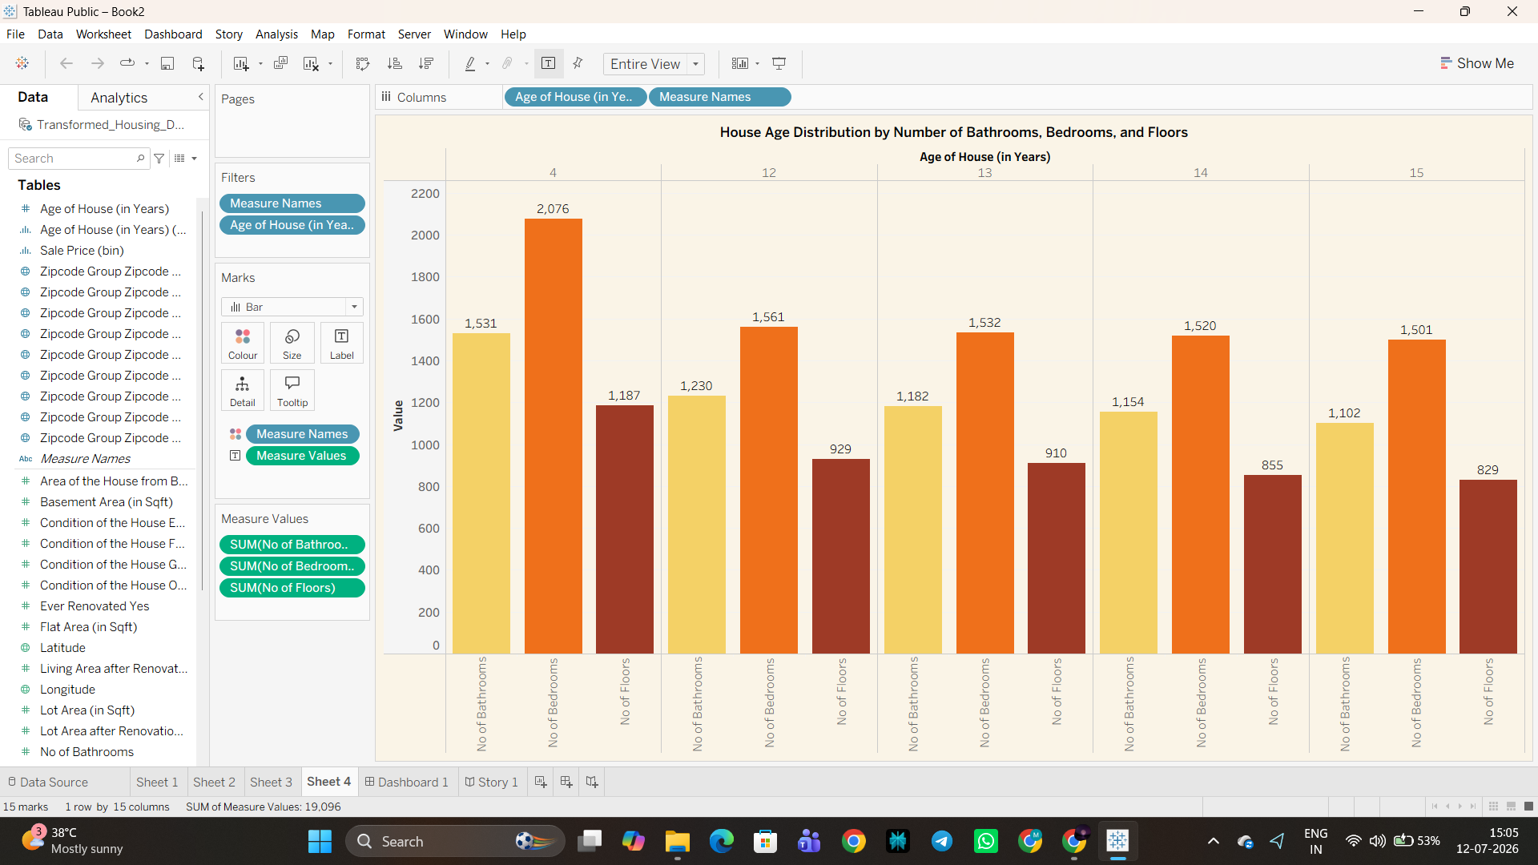  Data pane showing all housing dataset fields rendered in Tableau Public
2 | Data Preprocessing | Removed null values, verified data types, removed duplicate property records, created calculated fields (House Age, Years Since Renovation, Ever Renovated Yes, Sale Price bins), grouped Zipcode (1–9), and validated renovation and condition fields before visualization.  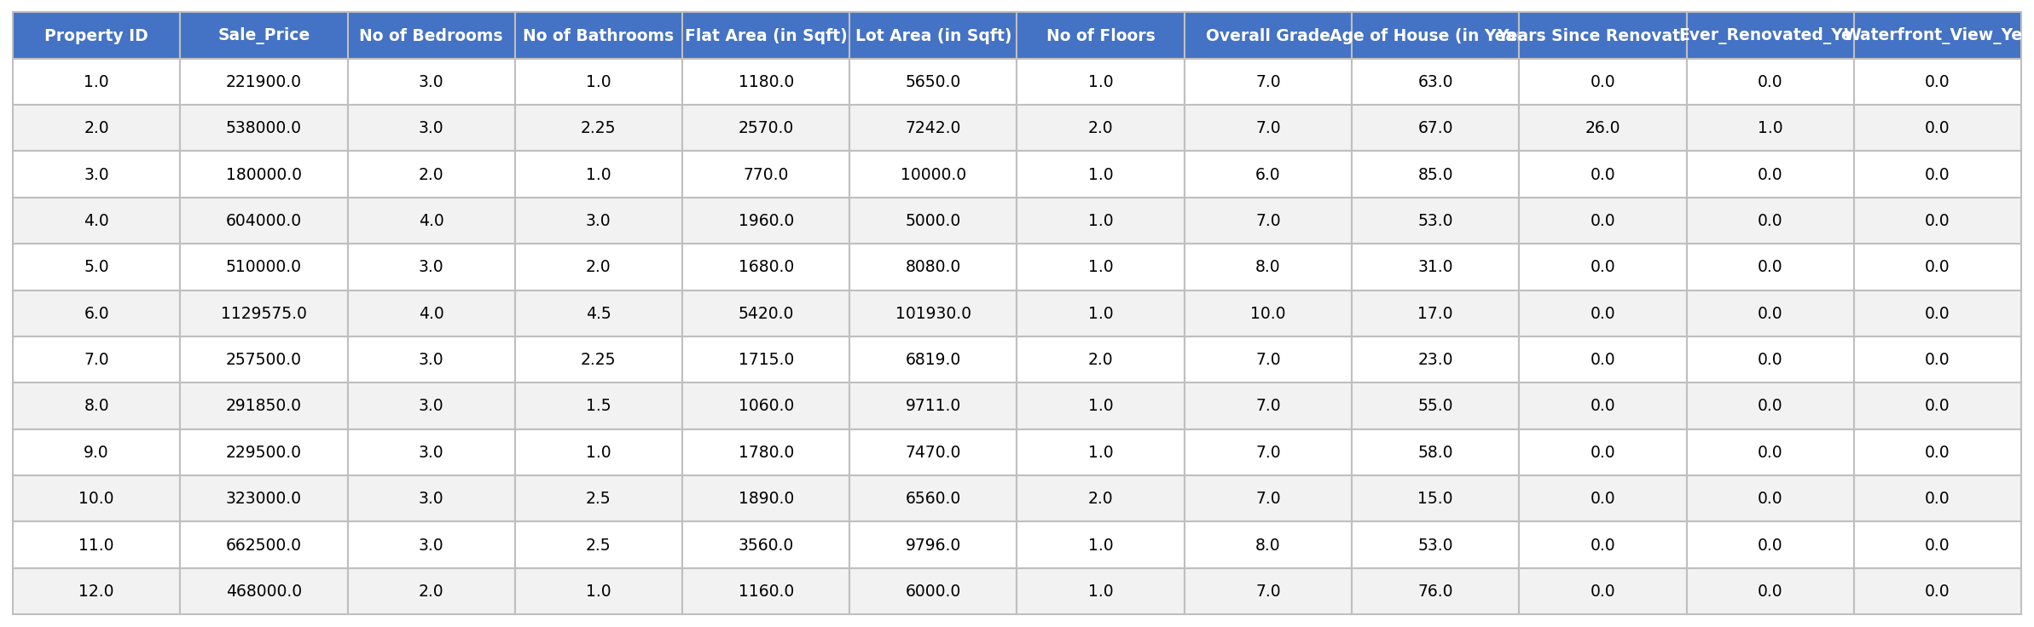  Cleaned and transformed housing dataset used for dashboard visualization
3 | Utilization of Filters | Filters used: Zipcode Group (1–9), Age of House (in Years), Sale Price (bin), No of Bedrooms, No of Bathrooms and Measure Names.  Aggregation functions: SUM(Sale Price) and CNT(Sale Price) were primarily used for the KPI totals (Total Properties, Total Basement Area), while AVG(Sale Price) was applied for the Avg. Sale Price KPI card. SUM(Ever Renovated Yes) drives the renovation-status pie chart, and SUM(No of Bedrooms), SUM(No of Bathrooms) and SUM(No of Floors) drive the house-age distribution chart.  Worksheets utilize coordinated filters — the Age of House (in Years) filter and Sale Price (bin) filter are applied consistently across Sheet 1, Sheet 3 and Sheet 4 — to allow synchronized cross-filtering between the KPI cards, the renovation-impact chart and the age-distribution chart on the dashboard.
4 | Calculation fields Used | Calculated fields created and used in this visualization include House Age, Years Since Renovation, Ever Renovated Yes (renovation-status flag), Sale Price (bin) and Zipcode Group.  Logic / Syntax:  - House Age = DATEDIFF('year', [Year Built], TODAY())  - Years Since Renovation = IF [Year Renovated] = 0 THEN [House Age] ELSE DATEDIFF('year',[Year Renovated],TODAY()) END  - Ever Renovated Yes = IF [Year Renovated] > 0 THEN 'Yes' ELSE 'No' END  - Sale Price (bin) = created using Tableau's Create Bins on Sale Price, with a fixed bin size for the sales-distribution chart  - Zipcode Group = raw zipcodes bucketed into 9 calculated groups (Zipcode Group 1–9) for location-wise analysis  Purpose: These calculated fields let the KPI cards, the Total Sales by Years Since Renovation chart, and the renovation/age breakdowns aggregate correctly at the dashboard level, without requiring row-level detail from the raw dataset.
5 | Dashboard design | All visualizations in use — Dashboard Design (Comprehensive House Data Analysis):  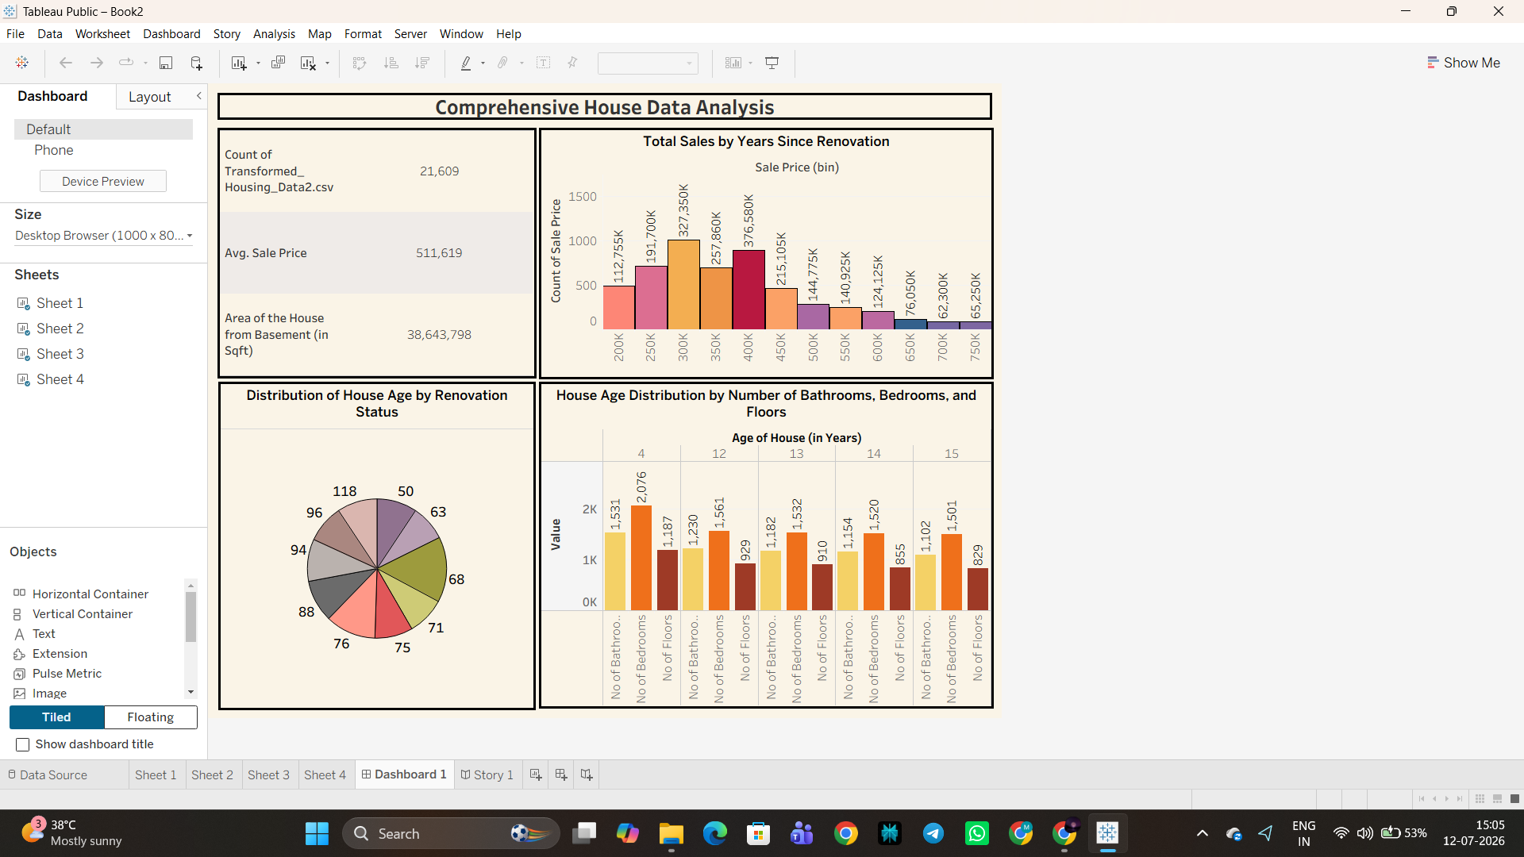  Comprehensive House Data Analysis — Tableau Public Dashboard  The dashboard combines the KPI summary panel (Total Properties, Avg. Sale Price, Area of the House from Basement) with the Total Sales by Years Since Renovation chart, the Distribution of House Age by Renovation Status pie chart, and the House Age Distribution by Number of Bathrooms, Bedrooms and Floors chart.
6 | Story Design | Visualizing Housing Market Trends using a Tableau Story. Multiple story points were created to narrate the housing-market findings in sequence: the importance of recent renovations in boosting property sales, how house age varies by renovation status, and how house-age distribution is influenced by the number of bedrooms.  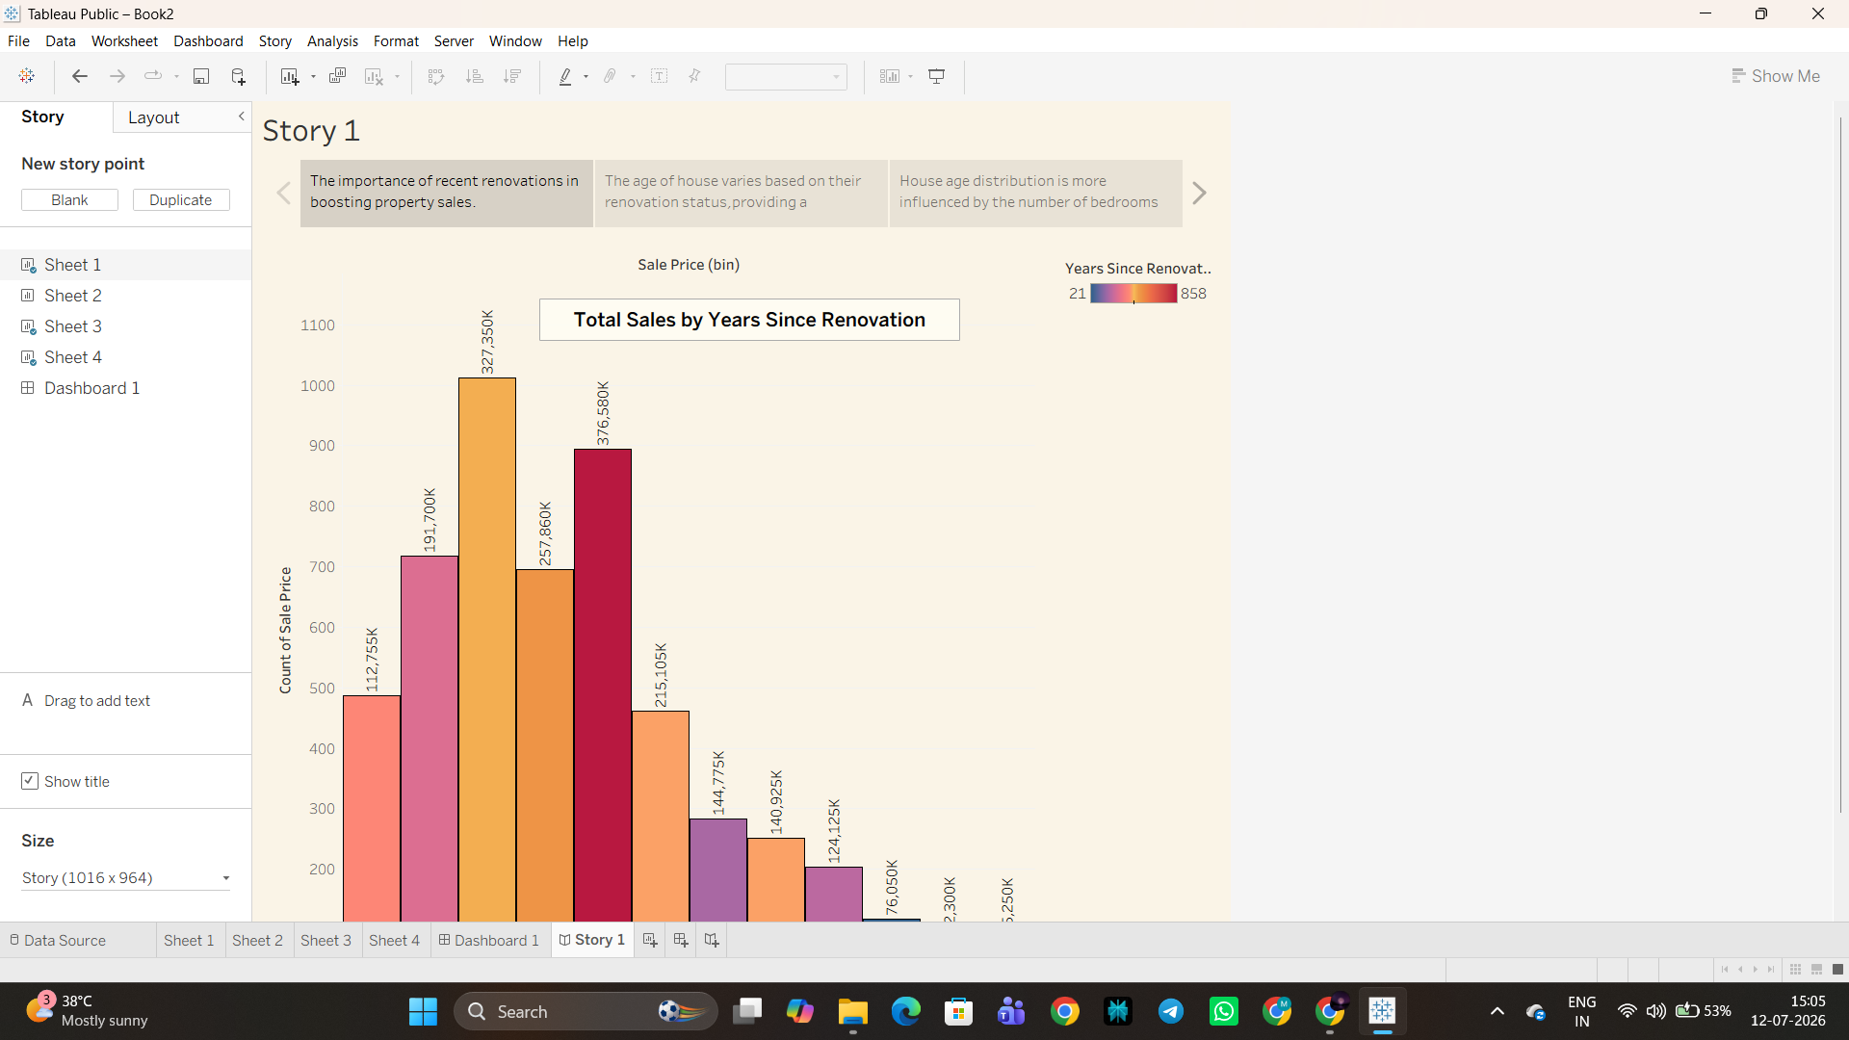  Story Point 1 — House Age Distribution by Number of Bathrooms, Bedrooms and Floors  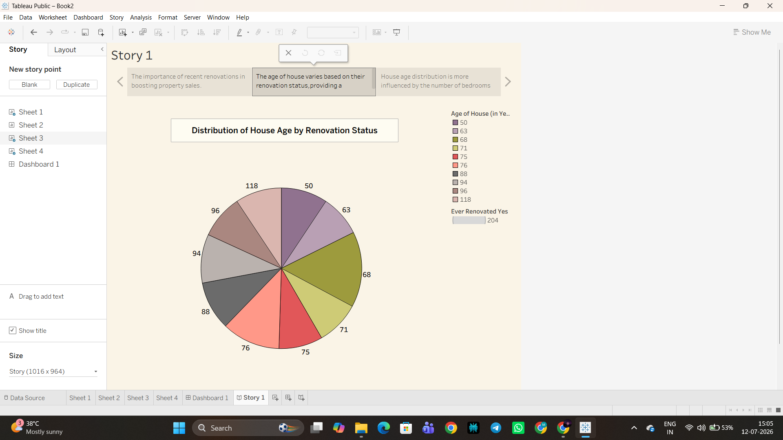  Story Point 2 — Distribution of House Age by Renovation Status  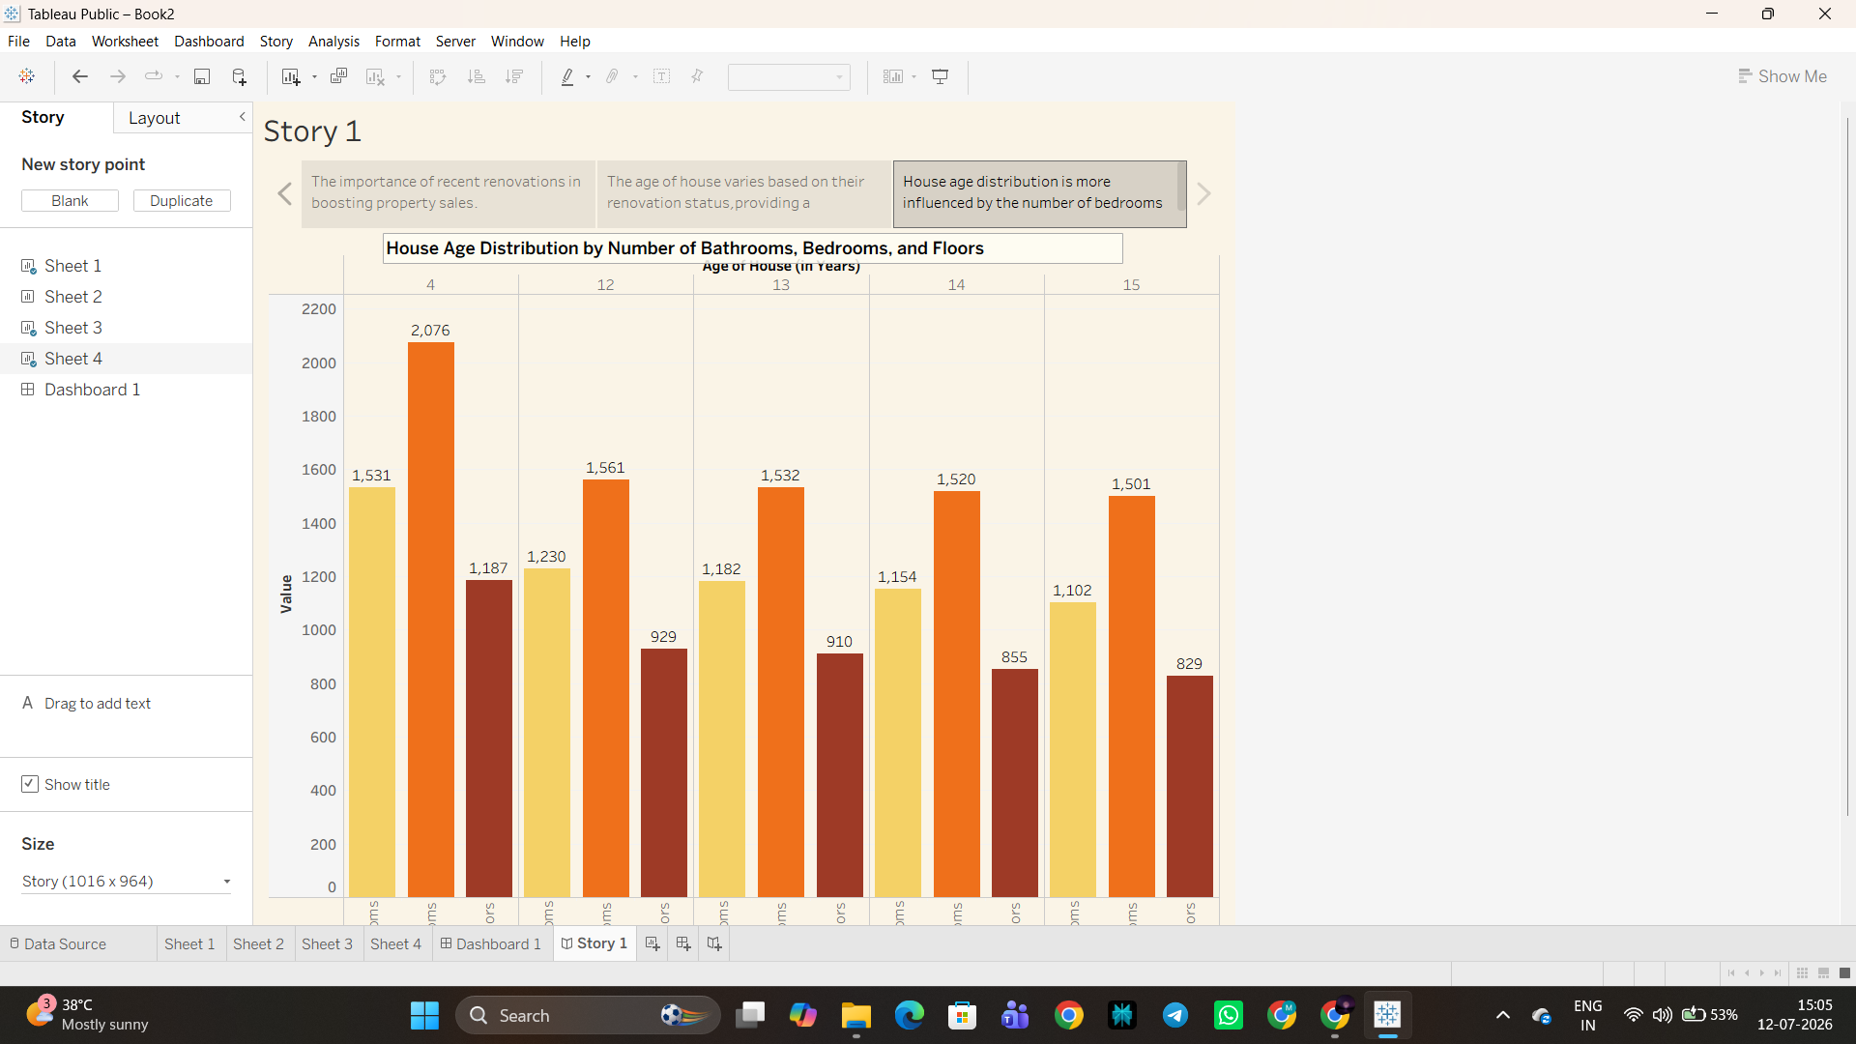  Story Point 3 — Total Sales by Years Since Renovation

